**Brooklyn torah gazette**

**For parshas toldos 5781**

Volume 5, Issue 10 (Whole Number 210) 5 Kislev 5781/ November 21, 2020

**Printed L’illuy nishmas Nechama bas R’ Noach, a”h**

This means, if one doesn't provide food to those who need it, he is held responsible for everything wrong that happens due to this error.

**Playing the Ball Wherever**

**The Monkey Drops It**

**By Daniel Keren**

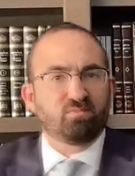

**Rabbi Joey Haber**

Yisroel Federman, a friend from shul recently emailed me a powerful three minute Torah video of Rabbi Joey Haber posted on Torahanytime.com titled “We Play it Where it is…” Rabbi Haber is the Dean of religious studies at Magen David Yeshiva High School in Brooklyn and is also the rabbi of the Magen David Synagogue. In the summer when many in his community move to Deal, NJ he serves as rabbi of Tiferet Torah and Ahava in the Jersey Shore town.

In the video, Rabbi Haber noted that there seem to be a lot of people with long faces, almost suffering from hysteria [because of the outcome of the recent Presidential elections.] He offered as a hope for the future the following true story.

200 years ago the British built the first golf course outside of Great Britain that would later be called the “Royal Calcutta” in Calcutta, India. It was and remains to this day one of the most beautiful golf courses in the world with stunning fairways and greens and tee shots.



**Monkey with the golf ball**

There was just one problem the organizers hadn’t taken into account. There were native monkeys in the area. Whenever a golfer would hit the ball, a monkey would be attracted by the white object and jump and grab it and take it somewhere else nearby and release it. They didn’t know what to do. First they put up fences and still the monkeys climbed over and grabbed the ball and dropped it elsewhere. Then they tried chopping down the trees but that didn’t stop the monkeys. They also tried removing the monkeys from the area, but they kept coming back and interfering with the balls.

**The Golf Club’s New Rule**

Finally they came up with a solution. The golf club issued a new rule that you played the ball wherever the monkey puts it. That means if the monkey puts the ball there, that is where you play the ball or if the monkey puts the ball in a different spot that is where you play the ball.

Rabbi Haber said that that is really the rule of life. We don’t decide what the future will be. [The monkey in the Royal Calcutta is really just a shaliach or agent of the Borei HaOlam (the Creator of the World)] Hashem gave us this president and then He gave us that president and then He gave us another president. It doesn’t matter who the president is. We must understand that wherever You Hashem place the ball that is where we play it. We don’t get upset! We don’t get hysterical or worked up! We may be thoughtful. We can be concerned. But we don’t lose hope, realizing that everything is in Hashem’s hands.

If you would like to view this important video, you can view or listen to it and 80 other inspiring videos recently posted by Rabbi Joey Haber by clicking Torahanytime.com and on the homepage clicking at the top the icon Speakers and then scroll down in alphabetical order to Rabbi Joey Haber.

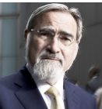

**Rabbi Lord Jonathan Sacks**

**Remembering Rabbi Lord Sacks**

The Jewish world has been deeply saddened by the loss almost two weeks ago on Shabbos Parshas Vayeira of two great Gedolim – Rav Dovid Feinstein, zt”l, America’s leading halachic (Jewish legal) posek (authority) and former Chief Rabbi of the United Kingdom, Jonathan Sacks, zt”l.

While I have viewed more than a score of Rabbi Sacks videoed lectures, I only once heard him speak in person when three years ago he was the keynote speaker at Congregation Beth Torah on Ocean Parkway in Brooklyn for a conference on the theme of “What Are the Limits of Jewish Responsibility?” I’d like to reprint three of the paragraphs from my article of his talk that appeared in the Jewish Connection:

“Even taking precedence over the popular concept of Tikun Olam, to save the world is the obligation of Jewish parents and the Jewish communities to ensure that they first save their own children from the dangers of assimilation and losing their connection to their essential Torah heritage.

“Rabbi Sacks quoted from recent Pew Research Center about the appalling state of the overall future of the Jewish community in America. The majority of Jews [who are not Orthodox] are abysmally ignorant of Jewish religious tradition. One of the questions asked to a sample of young Jews 30 years and younger was about religious identification, and a shocking 53 percent didn’t acknowledge their Judaism and wrote “nothing” for the category of religion.

“In response to this tragedy, Rabbi Sacks reiterated that before a Jew embarks on performing Tikun Olam, saving the rest of the world, he [or she] first must ensure that their own children and those of their community are taught a proper understanding and appreciation for their own Jewish religious heritage.”

*Reprinted from the November 20, 2020 email of the Jewish Connection.*

**Rabbi Berel Wein on**

**Parshat Toldot 5781**

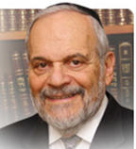

The question raised by all of the commentators who have dealt with this week's Torah reading is a simple one: How could it be that Eisav, a child who is raised in the house of great and holy parents, Yitzchak and Rivkah, could somehow turn out to be a terribly evil person – a murderer, rapist, thief and criminal?

It is difficult in the extreme to truly comprehend this issue. However, all the great commentators have attempted to deal with the matter in various forms and ideas. Some have attributed it to genetics – Eisav is a product of recessive genes inherited from Betuel and Laban and their ancestors, all of whom were pagan and evil. A recessive gene survives even when there are strong dominant genes present for many generations. And even the strong dominant genes of Abraham and Sarah, and Yitzchak and Rivkah cannot prevent the latent recessive genes from appearing and becoming dominant in one of their offspring.

**Failed to be Given the Education His Personality Required**

There are others who ascribe the aberrant behavior of Eisav to the fact that he did not receive an education that truly fitted his personality. He was a man of the field, a hunter and physically athletic. He was not cut out, as was his twin brother Yaakov, to sit for hours on end and study. Because of this mismatch of education and personality, the tragic figure of Eisav emerged.

Another theme that is represented in the commentaries is that the opposing views of Yitzchak and Rivka regarding their children, created an atmosphere in the home that exacerbated the differences between the children and drove Eisav to the extremes of behavior recorded for us in the Torah.

There are many other ideas and thoughts about the matter that appear in our holy Torah and we know that everything in the Torah contains 70 different layers of understanding and perspective. So, everything that can be said regarding the issue has merit and should be carefully considered when studying the matter.

A simple and perhaps more profound understanding of the matter is simply to reiterate and reinforce the basic idea that human beings, no matter what their ancestry may be and in whatever environment they are raised, retain the power of freedom of choice, especially regarding moral issues. One is righteous and pious not necessarily because that person's parents or ancestors were righteous and pious but rather because the person himself or herself chooses a path in life and behavior that would lead to righteousness and piety.

**We Are Ultimately Responsible for Our Actions**

We are all ultimately responsible for our behavior and our actions and basically all rationalizations and excuses regarding how we were raised, educated and trained are insufficient to remove from us the responsibility of our own personal choice of behavior and beliefs. The rabbis epitomized this in their statement that a human being is always responsible for his/her actions whether they be caused inadvertently or with malicious intent.

Eisav turns out to be Eisav because that is what he had chosen to be his goal in life. Like all human beings he may choose to rationalize and excuse his behavior, but ultimately, he alone is responsible for his life choices.

*Reprinted from this week’s website of rabbiwein.com*

**The Power of the Voice of Jacob and the Study of Torah**

**From the Talks of the Lubavitcher Rebbe**

**Rabbi Menachem Mendel Schneerson, Zt”l**

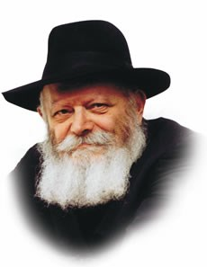

This week's Torah portion, Toldot, contains the famous story of Esau's sale of his first-born rights to his brother Jacob for a pot of porridge.

Subsequently, Jacob listens to his mother's advice and dresses up as Esau in order to receive the blessing of the first-born from his father, Isaac. "The voice is the voice of Jacob, but the hands are the hands of Esau," Isaac tells his son Jacob when Jacob comes to receive the blessings.

Our Sages comment on this verse that against the "voice of Jacob," Esau has "no hands," that is, he has no power or authority. When the "voice of Jacob" -- the voice and sound of Torah learning -- is heard, the "hands of Esau" -- the threats of the enemies of the Jewish people -- have no power over us.

The same holds true in reverse. When the voice of Torah is weakened, G-d forbid, the "hands of Esau" are able to overcome us. This latter alternative has already come to pass with the destruction of Jerusalem and the Holy Temple, as stated by the prophet Jeremiah: "For what reason was the land lost? Because they had forsaken My Torah."

In our times, too, nearly 2,000 years after the destruction of the Holy Temple, it must be emphasized that Jerusalem's existence still depends on the study of Torah. To be sure, we cannot change the facts of the past, but we are able to remove its cause and thus hasten the rebuilding and restoration of Jerusalem.

Our Sages state: "Any generation in whose days the Holy Temple is not rebuilt, it is reckoned against that generation as if it was destroyed in its time." The destruction is thus not simply an historical event that happened in the distant past. Its consequences extend to this very day, and the event, therefore, must be seen as something which is happening even now -- as if the Holy Temple, as it were, were being destroyed this very moment. It follows, then, that it is our duty (and we do have the ability) to rid ourselves of the cause of the destruction and prevent its present recurrence.

How can this be accomplished? Through the study of Torah.

The study of Torah is the antidote to the destruction, and will bring about the restoration of Jerusalem, the rebuilding of the Holy Temple, and the immediate revelation of our Righteous Moshiach!

*Reprinted from the Parshat Toldos 5756 edition of the L’Chaim Weekly, a publication of the Lubavitch Youth Organization. Adapted from Torat Menachem, Vol. 1 of the Rebbe.*

**The Firstborn’s Birthrights**

Yaakov said, 'Sell, as the day, your birthright to me. (25:31)

We read in this week’s parashah how Yaakov wrested the rights of the bechorah/ birthright from Esav. The midrash says that Yaakov used his Torah knowledge to accomplish this. How so?

R’ Avraham Abuchatzeirah z”l (20th century) explains as follows:

Another midrash says, “Why did Yaakov risk his life for the birthright? He saw that the sacrificial service in the then-future mishkan would initially be performed by the firstborn and later would be transferred to the kohanim.”

Yaakov learned from this that a firstborn can lose his rights, something which is not intuitively apparent. Why did the firstborn of the Exodus generation lose their rights? Because of the sins associated with the golden calf, i.e., idolatry and murder. (Bnei Yisrael killed Chur, who had rebuked them.)

Chazal say that on the day that Esav sold the birthright to Yaakov, Esav committed those very same sins – he denied the existence of G-d and he murdered Nimrod. If so, Esav, like the firstborn of the future, had forfeited his rights. This is what the above midrash means: Yaakov used his Torah knowledge to recognize that the prerogatives of the birthright were transferrable if the firstborn sinned. (Toldot Avraham)

*Reprinted from the Parshat Toldos 5781 email of whY I Matter parsha sheet of the Young Israel of Midwood (Brooklyn) edited by R’ Yedidye Hirtenfeld.*

**Rabbi Dovid Feinstein, Renowned Jewish Legal Authority, Dies at 91**

**By Shira Hanau**

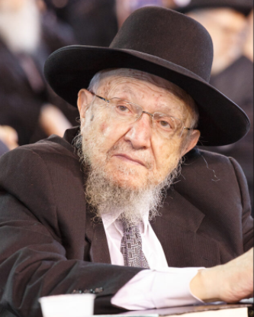

**Rabbi Dovid Feinstein led the Mesivtha Tiferes Yerushalayim yeshiva on the Lower East Side for decades, succeeding his late father. (Courtesy of Agudath Israel)**

([JTA](http://www.jta.org/)) — Rabbi Dovid Feinstein, one of the most prominent haredi Orthodox rabbis in the United States, has died. He was 91 years old.

The son of Rabbi Moshe Feinstein, one of the preeminent Jewish legal authorities in the United States for much of the 20th century, Feinstein served as the head of the Mesivtha Tiferes Yerushalayim on Manhattan’s Lower East Side from the time of his father’s death in 1986 until his own passing on Friday. He also served on the Moetzes Gedolei Hatorah, the rabbinical council connected to Agudath Israel, an umbrella organization representing haredi, or ultra-Orthodox, communities.

**A Dyed-in-the-Wool East Sider**

Though the Orthodox community on the Lower East Side has shrunk over the years as Orthodox communities in Brooklyn and other cities became more prominent, Feinstein continued to be a sought-out Jewish legal authority.

“He was a dyed-in-the-wool East Sider. He was very much a man of the neighborhood,” said Jonathan Boyarin, a professor of Jewish studies at Cornell University.

Boyarin spent a year studying at Feinstein’s yeshiva and chronicled the place in his recent book, “Yeshiva Days: Learning on the Lower East Side.”

Feinstein was born in Luban, which was then part of Russia and now Belarus, and came to the United States as a child in the 1930s. His father became head of the yeshiva at Mesivtha Tiferes Yerushalayim when the Lower East Side was a center of Jewish life in New York City, bringing together Orthodoxy, Yiddish secularism and radical Jewish politics in one cramped neighborhood. The elder Feinstein was considered one of the foremost Jewish legal experts and a communal leader in the United States until his death.

**Took Over as the Head of the Yeshiva**

After his father died, Feinstein took over as head of the yeshiva. By that time, the Jewish community of the Lower East Side had already begun to decline, though it remained a draw for those shopping for Jewish food and books. Over time, though, the community dwindled further as large Orthodox families decamped for more spacious parts of the city or to newer communities in New Jersey.

Today the yeshiva has an outpost on Staten Island in addition to the Lower East Side building, and many students travel to study at the yeshiva from their homes in larger Orthodox communities elsewhere in the city or New Jersey.

“It gradually became a smaller institution as the Orthodox population of the Lower East Side declined,” Boyarin said.

Still, Feinstein continued to be known as a foremost Jewish legal expert.

“During his lifetime, he certainly was the foremost figure,” Rabbi Dr. J. David Bleich, a professor of Jewish law and ethics at the Benjamin N. Cardozo School of Law, said of Feinstein’s stature in the world of Jewish legal decision-making.

Asked what made Feinstein such a prominent figure, Bleich answered simply: “Pure knowledge.”

“He was very much self-effacing, he didn’t seek the limelight,” Bleich said.

Unlike his father, who was also considered a major leader on communal issues affecting the Orthodox community, Feinstein’s authority was confined to the legal sphere — but it was significant.

**“The Limelight Chased Him”**

“The limelight chased him,” Bleich said of Moshe Feinstein. “Rav Dovid managed to get away from the limelight.”

Feinstein also departed from his father’s manner in that he issued few written opinions, instead answering Jewish legal questions orally.

“It’s very clear that he was reluctant to issue written psak [responsa] in most cases because he didn’t want his psak in a particular case to become precedent for cases where the situation might be different and even he might have ruled differently,” Boyarin said.

Hundreds attended Feinstein’s funeral, which began outside the yeshiva on East Broadway. In Israel, where he was buried, thousands attended his funeral. Two people were arrested at his funeral there, according to [The Times of Israel](https://www.timesofisrael.com/flouting-rules-thousands-attend-jerusalem-funeral-for-us-rabbi-dovid-feinstein/).

Orthodox organizations mourned Feinstein’s death.

“There are no words. We are reeling,” Rabbi Chaim Dovid Zwiebel, executive vice president of Agudath Israel, said in a statement. “Rabbi Feinstein was a true ‘manhig hador,’ leader of our generation, and ‘posek hador,’ halachic authority for the generation. The entire Jewish world has suffered a terrible blow with his death.”

**The Orthodox Union also issued a statement.**

“In addition to assuming his father’s role as head of the yeshiva, Rav Dovid was relied upon by the Torah community to succeed his father as a preeminent source of Halachic wisdom,” the O.U. said. “He provided a clear, steady and confident voice of Halachic guidance to innumerable individuals and institutions within the community.”

*Reprinted from the November 11, 2020 dispatch of the JTA (Jewish Telegraphic Agency.)*

**Parshas Toldos**

**Love Won’t Conquer All**

**By Rabbi Bentzion Shafier**

**Founder of TheSmuz.com**

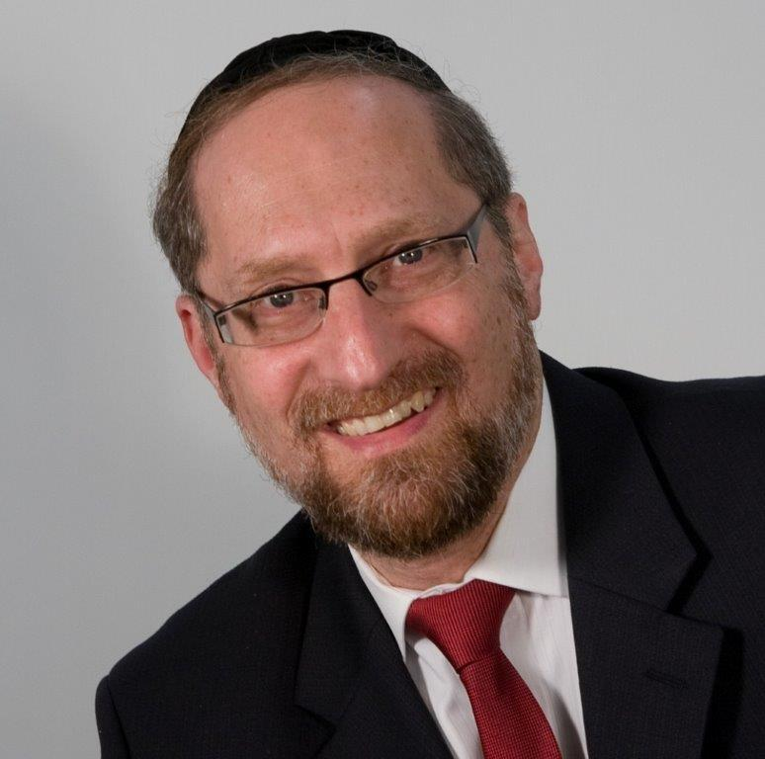

“And Yaakov approached Yitzchak his father, and Yitzchak felt him, and said, `The voice is the voice of Yaakov, and the hands are the hands of Aysav.’” — Bereishis 27:22

To “trick” Yitzchak into giving him the bracha, Yaakov donned Aysav’s clothing, put the skin of an animal on his arms and neck to simulate the hairiness of Aysav, and went in to his father to receive the blessing. As they were twins, the subterfuge was almost perfect, and it seemed as if Yaakov had succeeded. For all intents and purposes, he appeared as Aysav, spoke as Aysav, and presented himself as his twin. Yet something made Yitzchak suspicious, and he said the famous words: “The voice is the voice of Yaakov, and the hands are the hands of Aysav.”

Rashi explains what tipped Yitzchak off. Yaakov used the equivalent of the word “please,” as in “Please, my father, get up. Please, my father, take this.” These were words that Aysav would never utter. Therefore, Yitzchak suspected that it wasn’t Aysav, but rather Yaakov, and he asked to “feel” the person in front of him to determine which of the brothers it was.

This Rashi is very difficult to understand when we take into account Aysav’s relationship with his father.

**No One Fulfilled Kibud Av as Aysav Did**

Aysav had genuine respect and reverence for his father—in fact, he loved him. The Medrash Rabbah says that, “In the course of human history, no man ever treated his father with the respect that Aysav treated his father. So how is it possible that he was gruff and rude to a man who he loved and adored?

The answer to this question lies in understanding human nature.

**The Force of Habit**

We are engaged in thousands of interactions, choices, and decisions each day. Unlike an animal, which is preprogrammed to perform in a particular manner, the human has free will — free will to choose how he will respond, react and deal with every situation. If every one of his decisions was a conscious choice that had to be thought out, he would spend his entire day just making them.

A man is approaching. Do I smile and nod or do I look the other way? He’s looking at me, do I turn my head to respond or do I look out at the trees? When he asks me how my day is, does he expect a detailed inventory of actions or does he mean it in a casual manner?”

To allow us to function productively, HASHEM gave us the power of habit. Habit allows us to respond almost unconsciously to the thousands of choices that we are constantly engaged in. As a result, we can talk and eat dinner at the same time. We can drive a car, watch the traffic, change lanes, and hold a conversation. Most of the actions we engage in are done on auto-pilot. We don’t have to think about them. We have done them before, created our patterns of action and reaction, so now we can just go about our business without having to use up our conscious minds on rote activities. Habit governs and controls most of the actions and choices of our day.

**Habit is a Double-Edged Sword**

This force is a double-edged sword. It allows us to accomplish worlds more, but it costs us in the sense that bad habits and poor reactions can lock us into behaviors and responses that don’t accurately represent our will. We’re just stuck with them because of the ruts that we have created.

This seems to be the answer to Rashi. There is no question that Aysav deeply respected his father. But Aysav was gruff. His operating mode was curt and rude. Those were the habits that he developed, the manner in which he acted, the patterns that he etched into his soul. Even when he was in a situation of serving a man that he greatly respected, his years of mechanized routine surfaced, and he spoke the way that he usually spoke.

When Yaakov impersonated Aysav and used polite terms, it was out of character. Yitzchak noticed something out of synch. This wasn’t the Aysav that he had known for so many years.

This concept is very applicable in our lives on a number of fronts.

I love him, but can’t live with him

It may well be that we respect our parents, love our siblings, and are deeply attached to our spouses, but unless a person consciously works on his word choices, reactions, and responses, he may well be putting on a façade — presenting an image to others that doesn’t accurately reflect how he feels. The message he may be giving is very different from his inner condition.

**One of the Saddest Expressions**

One of the saddest expressions uttered in a troubled marriage is: “I love him, but can’t live with him.” Often times, it isn’t that the man is a selfish lout or a creep. It is simply that he has remained with the bad habits of being unpolished. “Please,” thank you,” and “excuse me” are lacking from his vocabulary.

This can make all the difference in the world between a person who is pleasant to be around — or not. The most amazing part is that these expressions don’t always represent who the person is and how he feels, but the little niceties of life are the grease that smoothes the wheels of social interactions.

While middos are the essence of a person, social graces often speak louder than feelings to those who actually live with him. By training our tongues in these social conventions, we give off a persona that matches our inner condition, and those we interact with get to experience the considerate, caring person that we are.

*Reprinted from this week’s website on TheShmuz.com This is an excerpt from the [Shmuz on the Parsha book](https://theshmuz.com/product/shmuz-on-the-parsha-book/).*

**Thoughts that Count for Parshat Toldot**

*A ladder was standing on the ground and the top of it reached to heaven.* (Gen 28:12)

The Hebrew word for ladder (sulam) has the same numerical value as money (mamon). This teachers us that money is like a ladder -- it can be used to ascend and come closer to the heavens, or with it one can descend to the depths. Everything depends on how we use it and for what purpose. *(The Baal Shem Tov)*

*The man [Isaac] became great, and grew more and more...* (Gen. 23:13)

It is common that as a person becomes richer, the person within him becomes smaller and smaller. The greatness of Isaac was that even though he became more and more wealthy, he increased and expanded in his qualities as a person. *(Rabbi Yitzchak of Torchow)*

*Isaac had grown old and his eyesight was failing.* (Gen. 27:1)

Rashi explained that Isaac's eyesight was failing him so that Jacob could receive the blessing. In order to assure that Jacob would receive the blessing was it necessary for Isaac's eyesight to fail him? Wouldn't it have been "easier" for G-d to have revealed to Isaac that Esau was wicked and therefore undeserving of the blessing? However, G-d didn't want to speak badly about Esau. If this is true concerning the wicked Esau, all the more must we be extremely careful not to gossip about or slander any Jew. *(The Lubavitcher Rebbe)*

*Reprinted from the Parshat Toldot 5756 edition of the L’Chaim Weekly, a publication of the Lubavitch Youth Organization.*

**Despite Pandemic, More**

**Than 100 New Emissaries Join the Ranks of Chabad**

**By Aharon Loschak**

After meeting enough Jewish residents who said they were the only Jews in town, Rabbi Aharon and Chaya Mushka felt that it was time to bring Chabad’s presence to Ville-d’Avray permanently

The [coronavirus](https://www.chabad.org/library/article_cdo/aid/4676981/jewish/Coronavirus-Resources-Inspiration.htm) pandemic has brought many venerable institutions to their knees this year, and many organizations and corporations are reorganizing, regrouping, and downsizing—waiting for better and healthier times.

Not Chabad-Lubavitch. Not by a long shot. Chabad is growing.

The thousands of Chabad-Lubavitch emissaries who are gathering online for the annual International Convention of Chabad-Lubavitch Emissaries (Kinus Hashluchim) this weekend will be welcoming into their ranks more than 100 new rabbinic couples who are taking up posts in many different capacities and locations, in scores of new Chabad centers around the world.

Each new emissary is facing his or her own individual challenges, and all are following the direction of [the [Lubavitcher] Rebbe, Rabbi Menachem M. Schneerson](http://www.therebbe.org/), of righteous memory to meet every challenge with a steadfast faith in G‑d, and positive commitment to instill a love of Torah and the joyous performance of mitzvahs. Every one of these couples is determined to overcome those challenges, and help the communities they serve deal with the pandemic, and grow in their Judaism in the face of it.

“Chabad’s continued and expanded efforts in this pandemic are very much in keeping with the Rebbe’s philosophy that nothing is insurmountable,” said Dr. Mark I. Rosen, Associate Professor in the Hornstein Jewish Professional Leadership Program at Brandeis University. “The desire to keep on growing and view as an opportunity what others would see as an obstacle is very much Chabad’s approach.”

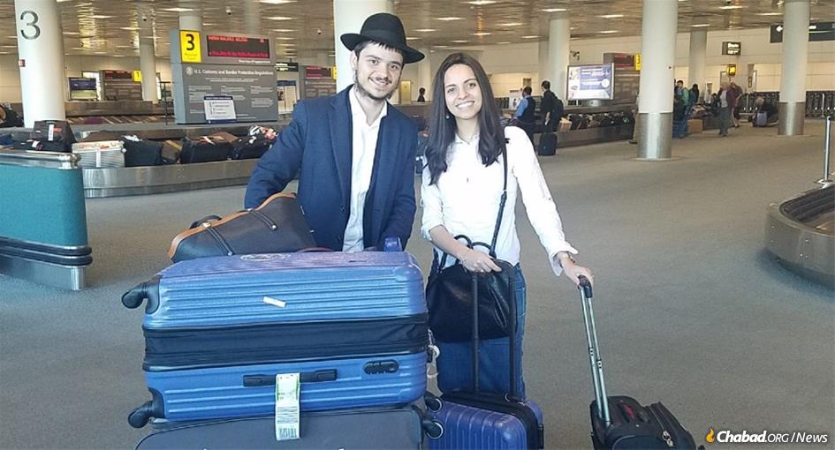

**Moving to Paris Amidst Growing Anti-Semitism**

Rabbi Aharon Chaya Mushka Mergui are one such couple. Natives of France, they long grew up with the dream of joining the Rebbe’s army of *shluchim* to the The Republic. To that end, Aharon started scouting the village of Ville-d’Avray, a small community to the west of Paris in the beginning of last year. Not known to be a place with a large Jewish representation, every Jew he met told Aharon of how they were the only Jew around, without any infrastructure to serve them.

After meeting enough Jewish residents with the same story, Aharon and Chaya Mushka felt that it was time to bring [Chabad’s presence to Ville-d’Avray](https://www.loubavitch.fr/delegues/profile/1146) permanently. After arranging all the necessary components with the central Chabad offices of France in Beth Loubavitch, they young couple began searching for a place to live.

**And Then the Pandemic Hit**

And then the pandemic hit. What should have been a quick search turned into a months-long quest, and finally, the Merguis found a place this summer.

With lockdowns and at best, strict guidelines of social distancing, Aharon and Chaya Mushka were faced with a tall task: to establish and grow a brand new community of Jews in a remote location with little to no in-person interaction.

They have taken up the challenge with gusto. Thanks to his ground game last year, Aharon has maintained constant contact with the people he met then, establishing connection over Zoom and some good old phone calls. So much so, the Merguis are running a full Hebrew School over Zoom.

“In a strange way, the coronavirus has brought new people to our virtual doors,” Mergui [told Chabad.org](http://www.chabad.org/news). “For example, for some Jewish people who live here, the holiday of Passover is the only time they will purchase kosher food. Stuck at home, many of them have turned to Internet searches in their quest to procure kosher food. We’re the local Jewish show in town, so they find us that way—and new connections are made.

“People have told us that while all other public services are downsizing or closing, we are creatively expanding more than ever. So many others are going into sleep mode, and we’re awakening ever more.”

**Uplifting Neighborhoods From Tel Aviv to Texas**

Mergui’s story is repeating itself in various formats all over the world. New shluchim have [paved the way in western Pennsylvania](https://www.chabad.org/news/article_cdo/aid/4818593/jewish/For-Chabad-Couples-Just-Starting-Out-a-Pandemic-Is-No-Barrier-to-Service.htm)—[Rabbi Yossi and Leah Feller](https://www.jewishcranberry.com/), have opened a Chabad center in Cranberry Township, Pa., about 20 miles due north of Pittsburgh, and [Rabbi Dovie and Mushkie Kivman](https://www.chabad.org/centers/default_cdo/aid/4736226/jewish/Chabad-of-Erie-County.htm) have opened their doors in Erie, Pa. Half way around the world, [Rabbi Chaim and Ofra Tverya](https://www.chabad.org/centers/default_cdo/aid/4619113/jewish/Chabad-Florentin.htm) and [Rabbi Menachem Mendel and Miryam Matusof](https://www.chabad.org/centers/default_cdo/aid/4652025)—have established new outposts in the rapidly gentrifying and uber-artsy neighborhood of Florentin, in Tel Aviv, Israel.

All told, the Rebbe’s army continues to surge, with the number of new soldiers willing to heed the call and venture forth never waning.

[Rabbi Mendy and Rikki Hertz](https://jewishsouthaustin.com/) have this in mind as they chart new waters in South Austin, Texas. Billed as the “fastest growing city in the United States,” the needs of the Jewish community are growing along with it. One who naturally enjoys a good conversation, Rabbi Hertz was looking forward to meeting people in his new place of living and stewarding a fledgling Jewish community into fruition.

Corona hit and upended much of those plans, but the basic goal remains the same: to reach as many Jews as possible and be there in any which way he can. All it takes is a little creativity.

**The Power of Social Media**

“With social media and so much of our lives now on the Internet, we have been able to meet new people and actually connect with them in a real way,” Hertz said. “And of course, the tried and tested method of calling people still works, and it has enabled us to operate despite the challenges. This pandemic has been a curveball, but we’re navigating it as best we can.”

Taking advantage of the naturally warm weather in Texas, Hertz and his wife Rikki are looking forward to setting up socially-distanced, limited, outdoor events that can further their goal of bringing Jewish life to their corner of the Lone Star State.

Of course, Hertz was looking forward to sharing experiences with fellow shluchim at the kinus this year. But, as he told Chabad.org, “We are all collectively inspired. The reality is that we’re all part of one gargantuan army, and our force lies in the similar inspiration that motivates us all.”

The pandemic has challenged us all, throwing one proverbial curveball after another at a world reeling to keep up. But the Rebbe’s inspiration that no challenge is insurmountable, and in fact, every challenge is simply a springboard for even greater growth rings truer than ever.

It’s the clarion call to which these 100 or so young couples have hearkened.

*Reprinted from the November 12, 2020 dispatch of Chabad.Org Magazine.*